|  |  |
| --- | --- |
| **Forum:** | United Nations Environmental Programme |
| **Issue:** | Address the issue of plastic pollution in the ocean |
| **Student Officer:** | Allison Luo |

**Overview**

Humans are the creature who primarily rely on plastic to survive on Earth. Humans become more satisfied and successful with the help of plastic because of its high accessibility and convenience. While benefiting from plastic, humans create more and more intensive damage to the natural environment and ecosystems over time by applying and discarding plastic in every second. Shown by the statistic, the production of global plastic has increased significantly since 1950. In 2016, a global population of over 7 billion individuals produced more than 335 million tons of plastic, which is equivalent to approximately 66 million African elephants. Every day, over 8 million pieces of plastic find their way into oceans. These number may set to be increased substantially in the future — probably be doubled by 2034. Plastic, long-lasting dust on Earth, not only cripples lives on land but also has adverse impacts on the marine species and ecosystems.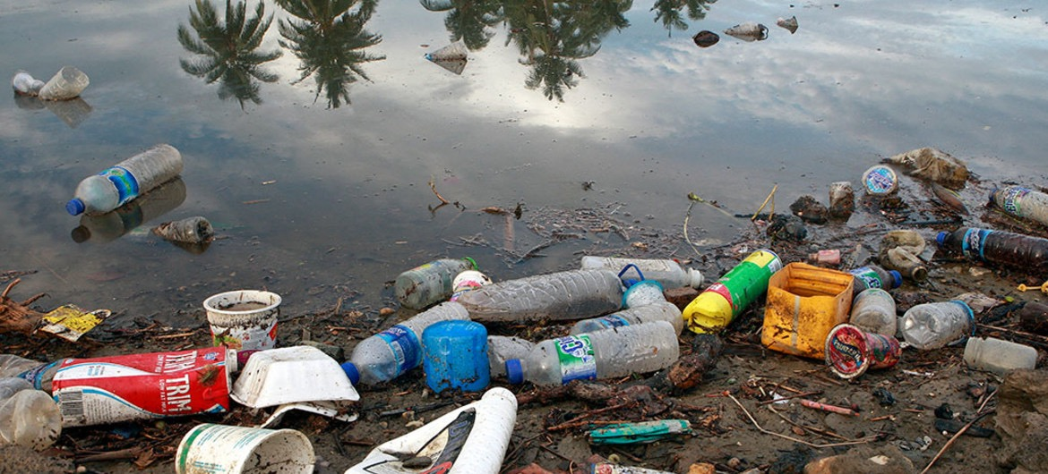

UN Photo — Plastic bottles and garbage waste from a village was on the shores of a river and then flow into the sea.

Due to the poor waste management, thousand and million tons of plastics are abandoned offshore, even threw directly into the oceans. Ocean currents across borders transport the plastic debris. Microplastics are embedded deep in the oceans. They are discovered everywhere, even on the remotest shores of uninhabited islands, the Arctic ice. The microplastic particles are located in a broad array of marine organisms, including the seafood that humans consume.

Plastics may cover marine species’ sources of food or place of living, causing habitat fragmentation or loss. Plastics may block a group of fish who is migrating and encompass them until energy loses and die. Turtle becomes deformity because its body is strapped by plastic over time. A Whale stranded on the beach in Norway was determined last year that there were more than 30 big plastic bags filled in its stomach rather than food. Some of the calves of whales have been poisoned by the contaminated milk the whales produced because of the mix of broken-down plastics with other pollutants.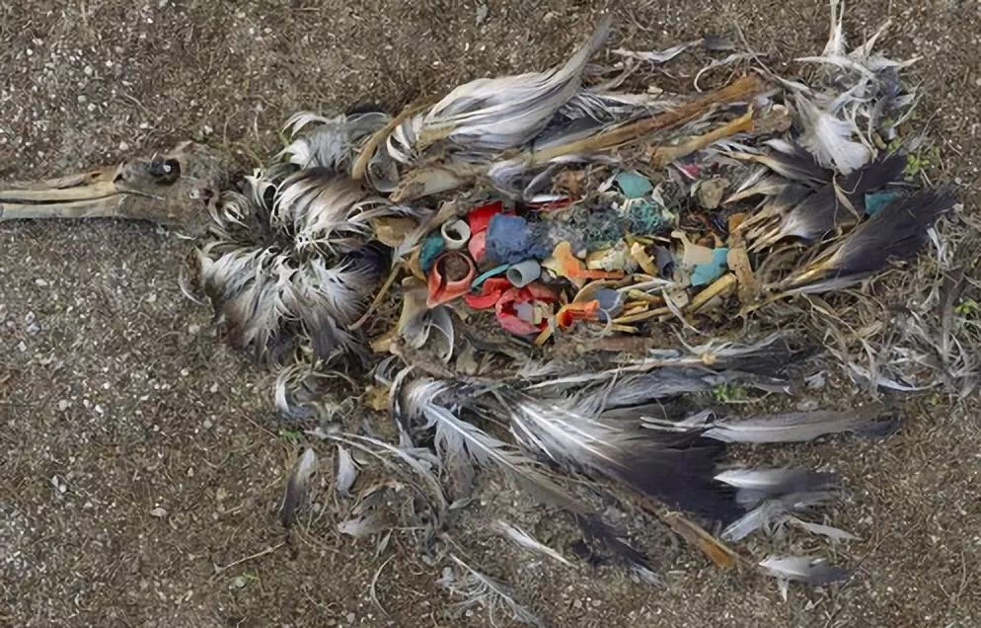

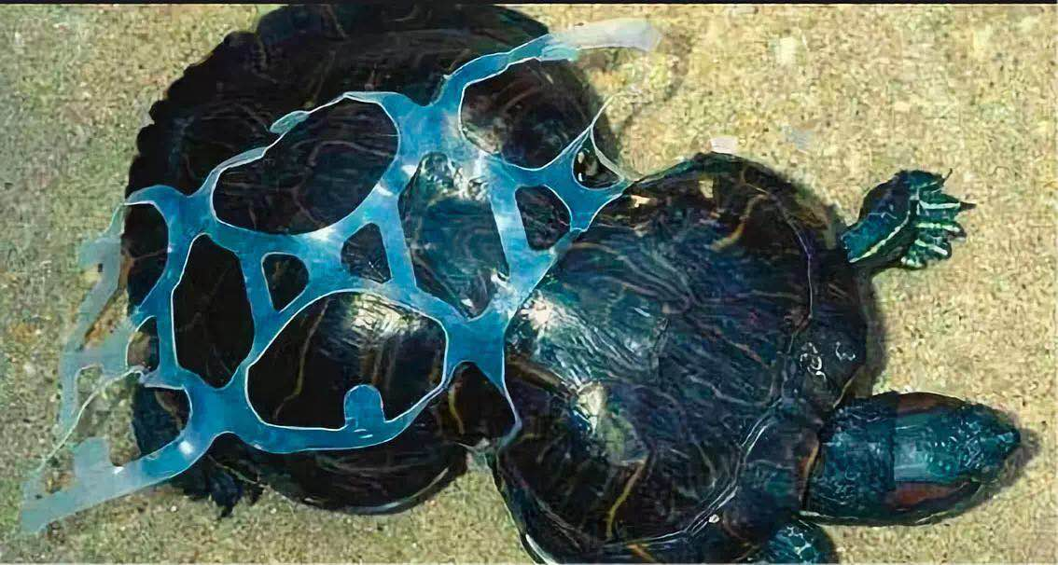

Recent researches have revealed plastic pollution in 100% of marine turtles, 59% of whales, 36% of seals and 40% of seabird species examined. “100,000 marine mammals and turtles and 1 million seabirds are killed by marine plastic pollution annually.” (Surfers Against Sewage) The marine species and ecosystems are experiencing annihilation by plastic pollution. Consequently, those destructions on marine life will influence human health. With the process of commercial fishing and consuming seafood, human will indirectly absorb toxic chemicals and contaminated nutrients.

According to a UN research, the costs of plastic pollution, including in repairing vessel damage, clean-up, and a decrease in tourism revenues, resulted from the marine debris was at around 13 billion dollars. As more and more marine biologists post their reports on plastic pollution and express their concerns, local governments, as well as the national and international organizations, begin to recognize its impacts to the natural environment and raise awareness to the public.

Besides, in order to combat this issue and promote ocean sustainability, United Nations sets Sustainable Developments Goals (SDG) 14: Conserve and sustainably use the oceans, seas and marine resources for sustainable development. UN believes that the threats of marine pollution, resource depletion, and climate change trigger more pressure on environmental systems, such as marine biodiversity and natural infrastructure, and problems of global socio-economy, such as security, health, and financial risks. UN sets its targets on SDG 14 such as sustainable protection and management of marine and coastal ecosystems by 2020, reduction and prevention of marine pollution of all kinds by 2025, and regulation of harvesting and end of overfishing and illegal fishing by 2020.

The consequences of plastic in the oceans are severe. Awareness is needed to be raised as well. Therefore, it is urgent for innovative solutions, which mitigate or prevent detrimental impacts on marine environments and support people who depend on oceans, to be placed.

**Key Terms**

**Plastic Pollution**

The accumulation of human-made plastic products in areas in the natural environment which results in problems to the wildlife and their habitats, as well as to human.

**Microplastics**

The small, barely visible plastic particles which work as pollutants in the environment. The sources of micro-plastics include the degradation from large plastic debris into small tiny pieces. Microbeads, an example of microplastic, are added as exfoliants to health and beauty products, which can easily travel through water filtration systems and end up in the ocean, resulting in a threat to aquatic life.

**Marine Debris**

Any persistent solid human-made materials, such as plastic, metals, papers that have been, directly or indirectly, accidentally or deliberately, disposed of or abandoned into the oceanic environment. Floating marine debris, also known as beach litter or tidewrack, tends to concentrate in the middle of gyres and on coastlines, which is frequently washing aground. They often result from the unintentional release of intermediate raw materials of plastics and occur as by-products of production or other processes from particulate emissions from industrial production or maintenance of plastic or plastic-based products.

**Photodegradable**

Substances that can be broken down by the action of ultraviolet rays presented in the sunlight.

**Biodegradable**

Substances that are capable of being decomposed by microorganisms, such as bacterias, naturally.

**Biomagnification**

The increasing concentration of substances, especially toxic chemicals, which appear in the tissue of tolerant organisms as those substances to move up the food chain. For example, a small fish eats plankton that has been contaminated by mercury.

**Ecological Restoration**

A practice of assisting the recovery of an ecosystem or habitat in a natural environment which has been degraded, damaged, or destroyed by human disturbances. More and more scientists and institutes involving in the restoration of marine habitats, such as the coral reefs which have degenerated because of anthropogenic activities.

**Conservation Biology**

The management of nature with the purpose of protection and preservation of species, habitats, ecosystems, and their biodiversity from extinction and the diminution of biotic interactions.

**Important Events/Timelines**

|  |  |
| --- | --- |
| **Date** | **Event** |
| **1960** | First reports of marine plastic debris impacting on marine species were published. |
| **1972** | Marine Protection, Research and Sanctuaries Act of 1972 (MPRSA )or Ocean Dumping Act, one of several key environmental laws, was passed by the US Congress in 1972, was has two essential focuses: to regulate intentional ocean disposal of materials, and to authorize any related research. |
| **1974** | The United Nations Environment Programme (UNEP) Regional Seas Programme, launched in 1974, is an international collaborative approach to address the degradation of the seas, to protect the marine environment and its resources, and to support the achievement of international environmental and development targets. |
| **1977** | United States Environmental Protection Agency published Ocean Dumping Regulations and dredged material testing guidance. |
| **April, 1989** | Second International Conference on Marine Debris in Honolulu |
| **December 29, 1993** | Convention on biological diversity enters into force with its purposes including the conservation of biodiversity and the sustainable use and fair and equitable sharing of natural resources.. |
| **1994** | Third International Conference on Marine Debris in Miami |
| **November 16, 1994** | United Nations Convention on the Law of the Sea (UNCLOS) enters the force, which defines the rights and responsibilities of nations with respect to their use of the world's oceans, establishing instructions for businesses, the management of marine natural resources. |
| **2000** | Forth International Conference on Marine Debris in Honolulu |
| **2005** | United Nations General Assembly delivers resolution on marine plastic pollution. |
| **2011** | Fifth International Conference on Marine Debris in Honolulu producing commitment and strategy. |
| **2012** | Global Partnership on Marine Litter Manila declaration |
| **2012** | Rio+ 20 Commitment to reduce marine debirs |
| **June 27, 2014** | Resolutions and decisions 1 adopted by the United Nations Environment Assembly of the United Nations Environment Programme at its first session on 27 June 2014 |
| **2016** | Resolutions and Decisions 2 adopted by the UN Environment Assembly at its second session. |
| **April 22, 2018** | Earth Day 2018 and beyond sets goal on end plastic pollution. |

**Major Nations/Organizations**

**United Nation Environmental Program (UNEP)**

The United Nations Environment Program is an international agency on behalf of the United Nations that is responsible for leading and coordinating action on environmental activities, and assisting countries to develop environmental policies and practices. It strives for #CleanSeas, highlighting global awareness of marine litter problem and promoting marine protected areas to attain their conservation and management.

**World Bank**

The World Bank is an international institution dedicated to providing financing support to countries to develop or involve in environmental programmes, including investing countries to enhance strong governance of marine and coastal resources for sustainable and inclusive economies.

**The United States Environmental Protection Agency (EPA)**

The United States Environmental Protection Agency is an independent organization of the United States federal government for environmental protection. For instance, EPA now is collaborating with counterparts from NOAA, State, U.S. Coast Guard, industry and other countries to assist the International Maritime Organization to achieve an action project to address the problem of marine plastic pollution generated by ships.

**National Oceanic and Atmospheric Administration (NOAA)**

The National Oceanic and Atmospheric Administration is a scientific agency of the United States within the United States Department of Commerce, focusing on the conditions of the oceans and the atmosphere. It is working with countries, national and international organizations to develop innovative solutions to tackle plastic pollution.

**International Maritime Organization (IMO)**

The International Maritime Organization is a specialized institution of the United Nations responsible for regulating shipping. It implements Assessment & Management of Environmental Pollution (AMEP) Programme to support countries in the Wider Caribbean to contribute to the implementation of the Cartagena Convention and its Protocols.

**Important Documents/Passed Solutions**

Resolution 1/6 on marine plastic debris and microplastics, United Nations Environment

Programme First session, 27 June 2014.

Resolution 2/11 on Marine plastic litter and microplastics, United Nations Environment Assembly of the United Nations Environment Programme Second session, 4 August 2016.

Documents on Combating marine plastic litter and microplastics: an assessment of the effectiveness of relevant international, regional and subregional governance strategies and approaches, Ad hoc open-ended expert group on marine litter and microplastics. The first meeting, the United Nations Environment Assembly of the United Nations Environment Programme, 8 May 2018.

Documents on Inputs to the Secretary-General's Report on Marine Debris, Plastics, and Microplastics, United Nations Environment Programme, 2016.

Documents on Combating marine plastic litter and microplastics: An assessment of the effectiveness of relevant international, regional and subregional governance strategies and approaches, the United Nations Environment Assembly of the United Nations Environment

Programme Third session, 5 October 2017.

Document on Marine plastic debris and microplastics – Global lessons and research to inspire action and guide policy change, United Nations Environment Programme, Nairobi, 2016.

**Statistic**

(1)Countries that contribute to increased marine plastic pollution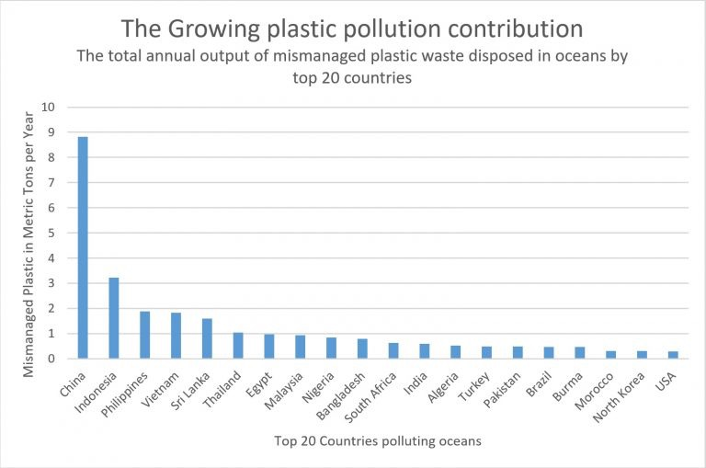

(2) Cumulative plastic waste generation and disposal (in a million metric tons) — Solid lines demonstrates historical data from 1950 to 2015; dashed lines show predictions of historical trends to 2050.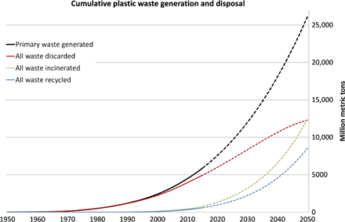

(3) Plastics and food web

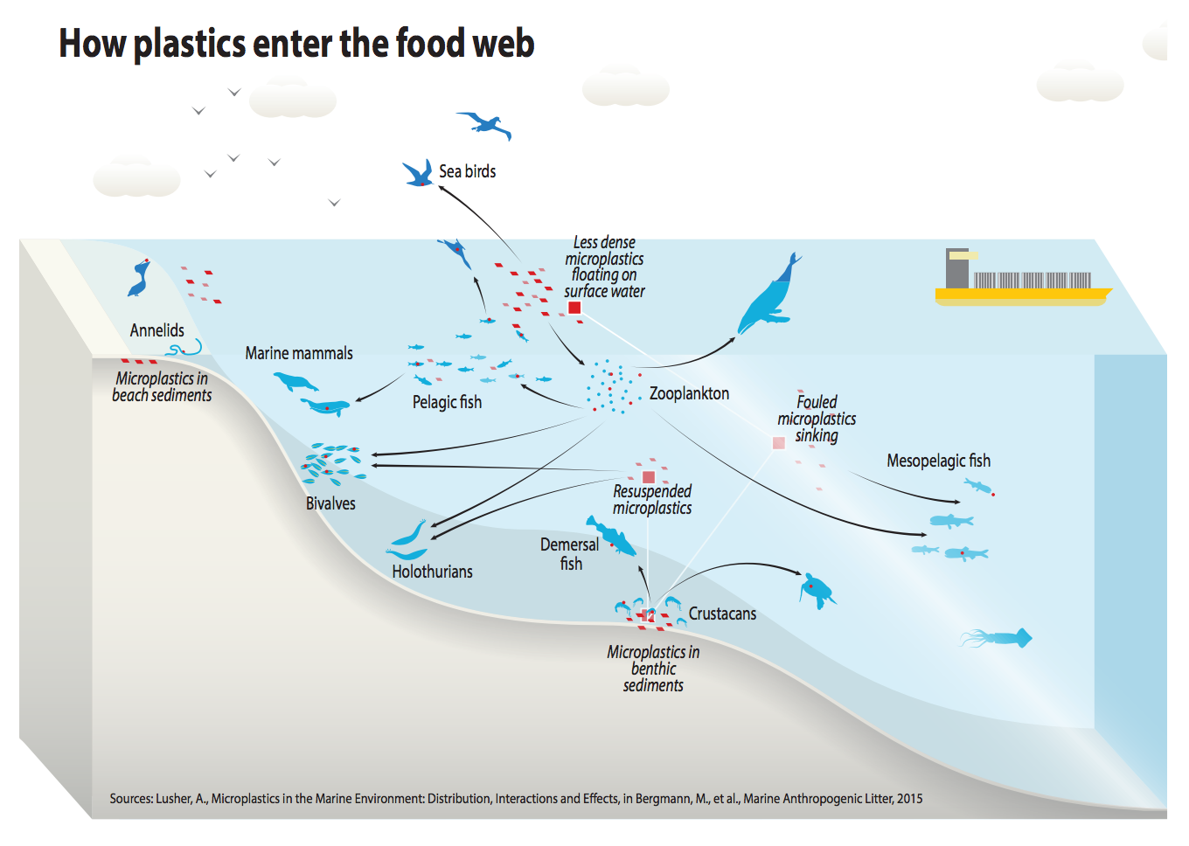

**Possible Solutions**

Plastic litters have already caused damaged marine species and ecosystems. Indeed, plastic pollution in the marine environment cannot be solved utterly in a relatively short period. While action against marine pollution is widespread and rampant, what most solutions lack is proper enforcement.

First and foremost, collaboration takes a significant role in addressing this problem. Delegates of different countries are expected to demonstrate a willingness or enthusiasm to cooperate with other member states and national or international organizations to develop solutions and environmental projects. While collaborating, members may consider his/her nation’s strengthens or weaknesses to achieve goals efficiently and effectively.

Furthermore, since plastics are one of the essential products which are applied to daily human life, member states should consider eliminating marine plastic pollution, while maintaining world economic development. Thus, members states of the United Nations could concern more on the sustainable use of plastic products and their disposal, such as recycling.

In addition, rather than only inviting governments or international institutions to participate in addressing this global issue, delegate of each nation may encourage more citizens to involve in building a better marine environment.

Above are some ideas but not limited to those. There are a variety of ways to address this global environmental problem. Members should always recognize that the resolutions should be realistic and profound, developing specific statements.

**Bibliography**

“EMUN 2017 Enviromental Commission – Measures to Combat Plastic Pollution in Water .” by Sofia Lacoppola , and Alejandro Chang.

Fabres, Joan, et al., editors. *Marine Litter Vital Graphics*. UNEP and GRID-Arendal, 2016, *Marine Litter Vital Graphics*, wedocs.unep.org/bitstream/handle/20.500.11822/9798/-Marine_litter_Vital_graphics-2016MarineLitterVG.pdf.pdf?isAllowed=y&sequence=3.

“FEATURE: UN's Mission to Keep Plastics out of Oceans and Marine Life | UN News.” *United Nations*, United Nations, 27 Apr. 2017, news.un.org/en/story/2017/04/556132-feature-uns-mission-keep-plastics-out-oceans-and-marine-life.

Geyer, Roland, et al. “Production, Use, and Fate of All Plastics Ever Made.” *Science Advances*, American Association for the Advancement of Science, 1 July 2017, advances.sciencemag.org/content/3/7/e1700782.

“GOAL 14: Life below Water.” *UN Environment*, www.unenvironment.org/explore-topics/sustainable-development-goals/why-do-sustainable-development-goals-matter/goal-14.

“How Microplastics Are Generated.” *GRID-Arendal*, www.grida.no/resources/6929.

*Marine Plastic Debris and Microplastics – Global Lessons and Research to Inspire Action and Guide Policy Change.* . United Nations Environment Programme, 2016, *Marine Plastic Debris and Microplastics – Global Lessons and Research to Inspire Action and Guide Policy Change.* .

“Ocean Dumping Management Timeline.” *EPA*, Environmental Protection Agency, 12 Mar. 2018, www.epa.gov/ocean-dumping/ocean-dumping-management-timeline.

“Plastic Pollution - Facts and Figures • Surfers Against Sewage.” *Surfers Against Sewage*, www.sas.org.uk/our-work/plastic-pollution/plastic-pollution-facts-figures/.

“Plastic Statistics.” *Ocean Crusaders*, 26 Mar. 2018, oceancrusaders.org/plastic-crusades/plastic-statistics/.

Pravettoni, Riccardo. “Marine Plastics Global Policy Timeline.” *GRID-Arendal*, 2018, www.grida.no/resources/6916.

“Protecting the Marine Environment.” *EPA*, Environmental Protection Agency, 24 Oct. 2018, www.epa.gov/international-cooperation/protecting-marine-environment.

“SDG 14: Conserve and Sustainably Use the Oceans, Seas and Marine Resources for Sustainable Development.” *SDG Compass*, sdgcompass.org/sdgs/sdg-14/.

Thompson, Richard C. *Future of the Sea: Plastic Pollution*. Foresight, Government Office for Science, 2017, *Future of the Sea: Plastic Pollution*, assets.publishing.service.gov.uk/government/uploads/system/uploads/attachment_data/file/634433/Future_of_the_sea_-_plastic_pollution_final.pdf.

“UN Report Finds Marine Debris Is Harming More than 800 Species, Costing Countries Millions - United Nations Sustainable Development.” *United Nations*, United Nations, www.un.org/sustainabledevelopment/blog/2016/12/marinedebris/.

“UNEP Regional Seas Programme Definition| Biodiversity A-Z.” *UNEP Regional Seas Programme Definition | Biodiversity A-Z*, www.biodiversitya-z.org/content/unep-regional-seas-programme.

US Department of Commerce, and National Oceanic and Atmospheric Administration. “What Are Microplastics?” *NOAA's National Ocean Service*, 13 Apr. 2016, oceanservice.noaa.gov/facts/microplastics.html.